Paper Template
Author^{1,*}, Author¹, and Author²
1Dept. name of organization (of Affiliation),
2 Dept. name of organization (of Affiliation)
*Corresponding author: author@pmu.edu.my
Abstract
Paper can be submitted in English and Bahasa Malaysia. Abstract should between 200-250 words. *CRITICAL: Do Not Use Symbols, Special Characters, Footnotes, or Math in Paper Title or Abstract. This electronic document is a “live” template and already defines the components of your paper [title, text, heads, etc.] in its style sheet.
Keywords: - component, formatting, style, styling, insert

1 Introduction
Use A4 paper size (210 x 297 mm) and adjust the margins to those shown in Table 1.
Table 1: Setting word’s margins.
Margin | mm
Top | 25
Bottom | 20
Left | 20
Right | 20
1.1 Formatting the title
The title is set in bold 12-point Times New Roman, justified. The first letter of the title should be capitalised with the rest in lower case.
1.2 Formatting the text
The text of your paper should be formatted as follows:
10-point Times, Times Roman or Times New Roman.
- The text should be set to single line spacing.
- Paragraphs should be justified.
2. Literature Review
Equations should be centred and should be numbered with the number on the right-hand side as shown in Equation (1).
A = B+C (1)
3. Methodology
Figures and tables, as originals of good quality and well contrasted, are to be in their final form, ready for reproduction, pasted in the appropriate place in the text.
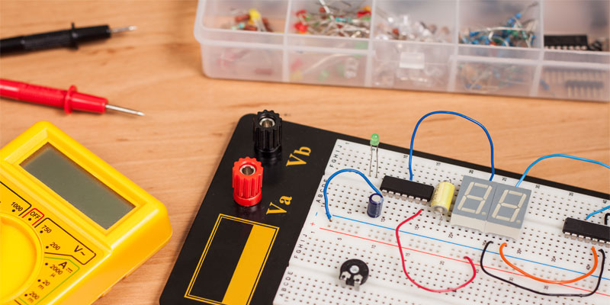

Figure 1 : Construct the electronic circuit
4. Finding and Analysis
Define abbreviations and acronyms the first time they are used in the text, even after they have been defined in the abstract.
5. Conclusion
Use either SI (MKS) or CGS as primary units. (SI units are encouraged.) English units may be used as secondary units (in parentheses). An exception would be the use of English units as identifiers in trade, such as “3.5-inch disk drive.”
Avoid combining SI and CGS units. This often leads to confusion because equations do not balance dimensionally. If you must use mixed units, clearly state the units for each quantity that you use in an equation.

Acknowledgment
The preferred spelling of the word “acknowledgment” in America is without an “e” after the “g.” Avoid the stilted expression “one of us (R. B. G.) thanks ...”. Instead, try “R. B. G. thanks...”. Put sponsor acknowledgments in the unnumbered footnote on the first page.

References
Use the APA Referencing Style 6th edition for the references and the minimum number of references is 10. The pdf file for “A Guide to APA Referencing Style: 6th Edition” can download by using this link

https://www.phdfood2019.it/wpcontent/uploads/2019/05/APA_Guide_2017.pdf

